**poler rules**

1_Roy Flush



2_Straight Flush



3_Four of Kind



4_full house



5_ Flush

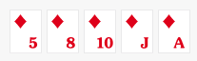

6_Straight

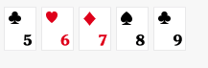

7_ Three of A kind = triple



8_Two Pair



9_ One pair

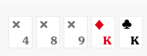

10_ high cards